EXP NO:02 DATE:
DESIGN OF HALF-WAVE AND FULL-WAVE RECTIFIER CIRCUITS USING TINKER CAD
AIM:
Design half-wave and full-wave rectifier circuits, simulate them in Tinker CAD, and verify performance by observing waveforms and calculating ripple factors.
SOFTWARE REQUIRED
- Tinker CAD

SOFTWARE DESCRIPTION
TinkerCAD is an online tool—no downloads required. It is designed for beginners, especially students and hobbyists. It allows users to create 3D models using simple shapes. It lets users build and test circuits virtually. It Offers a visual programming approach to create 3D designs using code. It is accessible at no cost with just a web browser and internet connection. It Supports sharing and collaborative work among students or teams. It is Backed by a major design software company, ensuring reliability and development support.

THEORY
A half-wave rectifier converts alternating current (AC) into pulsating direct current (DC) by allowing only one half of the AC cycle to pass. It uses a diode that conducts current during the positive half-cycle and blocks current during the negative half-cycle.The output is unidirectional but not smooth; it consists of pulses separated by gaps (during negative cycles).Basic components include an AC source, a diode, and a load resistor.It is used in simple power supplies and signal demodulation where full-wave rectification is not required.
A full-wave rectifier converts the entire AC input (both positive and negative halves) into pulsating DC output. It uses two diodes (center-tap transformer method) or four diodes (bridge rectifier) to conduct during both halves of the AC cycle. The output is continuous pulses without gaps, making it more efficient and smoother than a half-wave rectifier. Typically includes an AC source, diodes (2 or 4), a load resistor, and optionally a capacitor for smoothing. It is used in DC power supplies, chargers, and electronic devices where a stable and efficient DC output is needed.
PROCEDURE:
- Open Tinkercad → Circuits → Create New Circuit.
- Place the required components.
- Make the circuit connections.
- Set the AC source to 12 V, 50 Hz.
- Start the simulation.
- Observe and record the input and output waveforms

CIRCUIT DIAGRAM
Half wave rectifier: WITHOUT CAPACITOR FILTER AND WITH CAPACITOR FILTER:

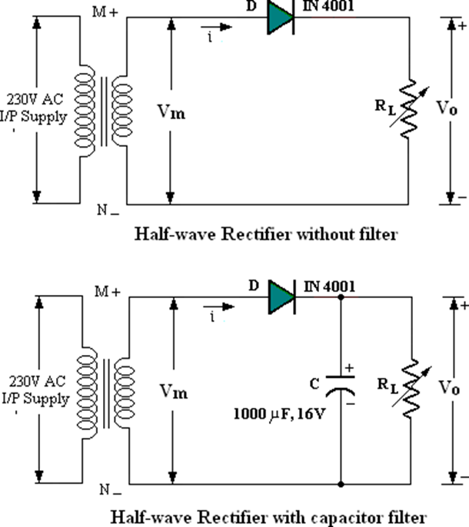

WAVE SHAPES:
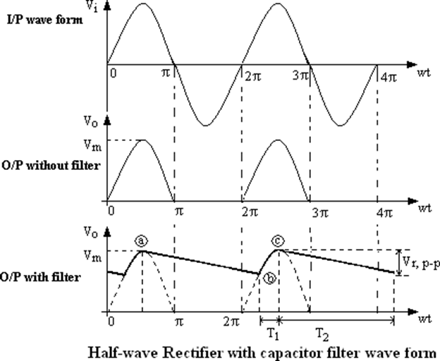

Full Wave Rectifier :WITHOUT FILTER AND WITH FILTER:
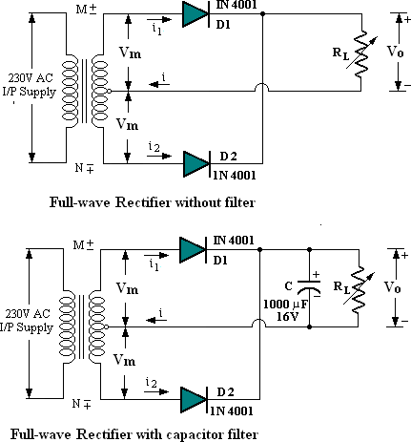
WAVE SHAPES:
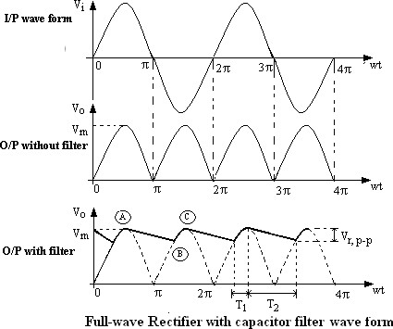

RESULT

Thus the Half wave rectifier and full wave rectifier with and without filter is simulated using tinker CAD and the wave forms are plotted

